🔷 OVERALL ROADMAP (6–8 Weeks)
Phase | Project | Duration
Phase 1 | Mini Project 1 – Delta Lake ETL | 4–5 days
Phase 2 | Mini Project 2 – Streaming Pipeline | 4–5 days
Phase 3 | Mini Project 3 – SCD Type 2 | 3–4 days
Phase 4 | Major Project 1 – Retail Analytics | 2–3 weeks
Phase 5 | Major Project 2 – Airline Analytics | 2–3 weeks

🔹 MINI PROJECT 1
ETL Pipeline using Delta Lake (Bronze → Silver → Gold)
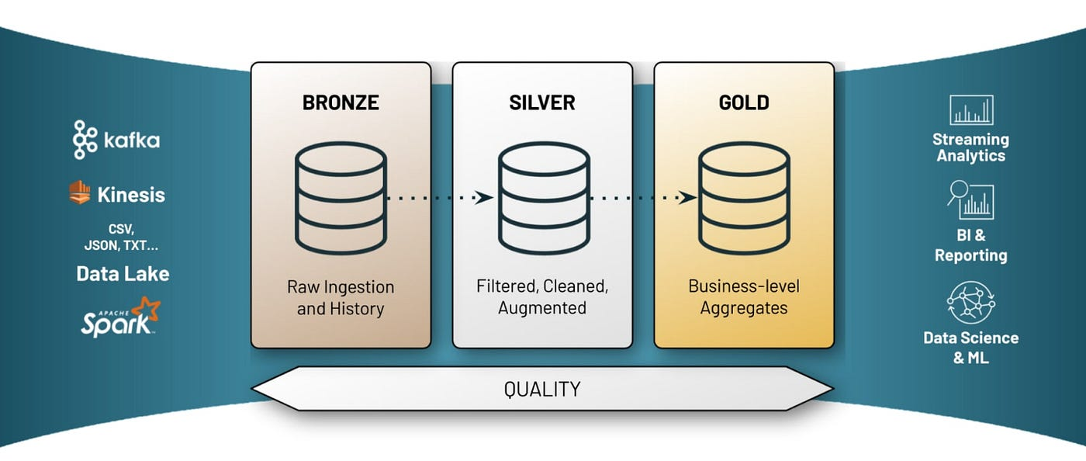

🎯 Objective
Build a batch ETL pipeline with:
- Schema enforcement
- Incremental loads
- Data quality handling
📁 Folder Structure
mini_etl_delta/
├── bronze_ingestion.py
├── silver_cleaning.py
├── gold_aggregations.py
├── utils/
│ ├── config.py
│ └── dq_checks.py
🧱 Implementation Steps
- Bronze Layer
  - Read CSV/JSON from cloud storage
  - Add metadata (ingest_ts, source_file)
  - Write as Delta (append)
- Silver Layer
  - Remove duplicates
  - Handle nulls
  - Standardize column names
- Gold Layer
  - Aggregations (daily sales, counts)
  - Partition by date
  - Z-ORDER on keys
🔑 Key Concepts
- Delta schema evolution
- Time travel
- OPTIMIZE + VACUUM

🔹 MINI PROJECT 2
Streaming Pipeline (Structured Streaming + Delta)
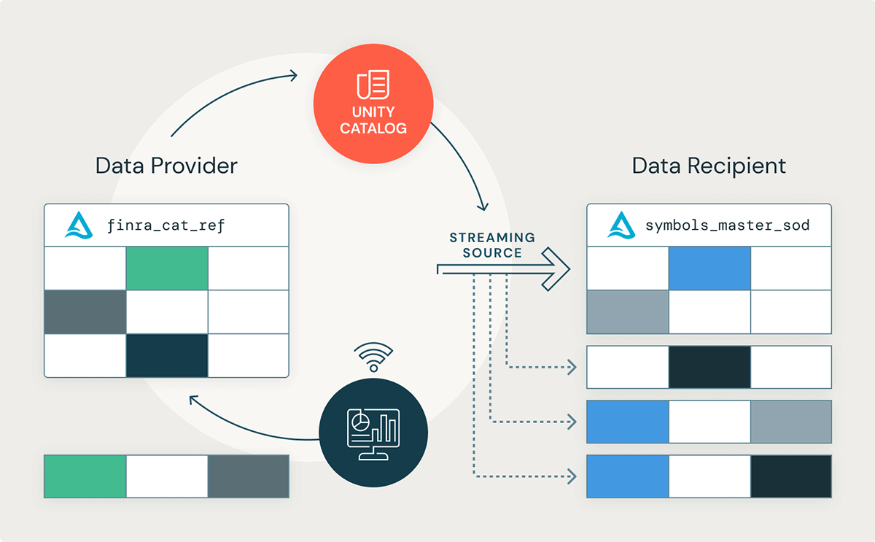
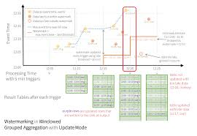
🎯 Objective
Ingest near real-time data and merge it with batch data.
🧱 Implementation Steps
- Streaming Source
  - Simulated Kafka / Auto Loader (JSON files)
- Stream Processing
  - Window aggregations
  - Watermarking
- Sink
  - Delta tables (append & merge)
🔑 Key Concepts
- Exactly-once semantics
- Checkpointing
- Late-arriving data

🔹 MINI PROJECT 3
Slowly Changing Dimension (SCD Type 2)
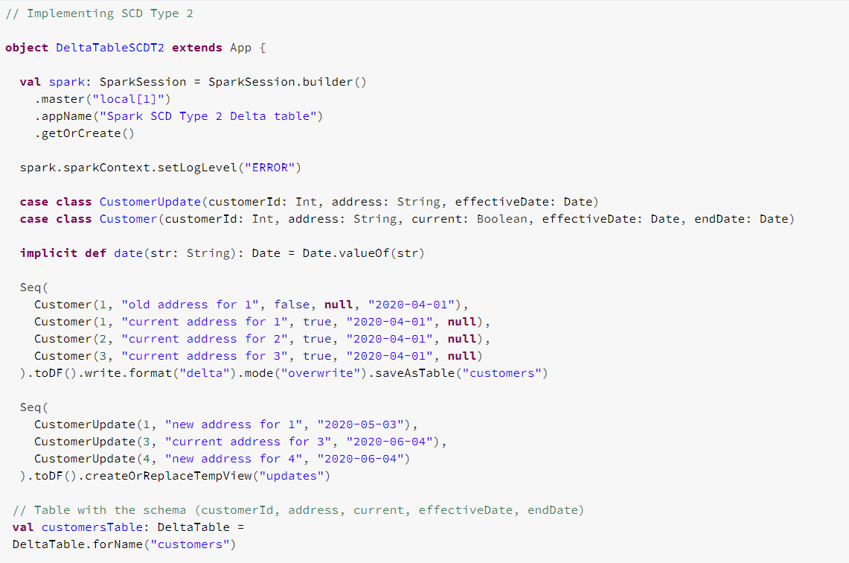
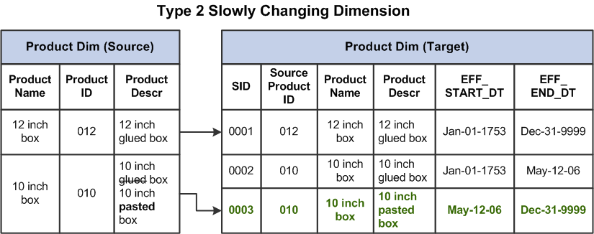
🎯 Objective
Track historical changes in dimension data.
🧱 Implementation Steps
- Create dimension table with:
  - effective_from
  - effective_to
  - is_current
- Implement MERGE logic
- Handle reprocessing safely
🔑 Key Concepts
- Idempotent pipelines
- Delta MERGE
- Data warehouse modeling

🔷 MAJOR PROJECT 1
End-to-End Retail Analytics Platform
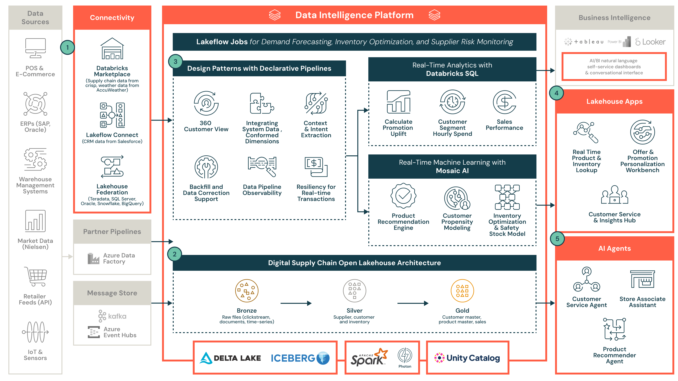
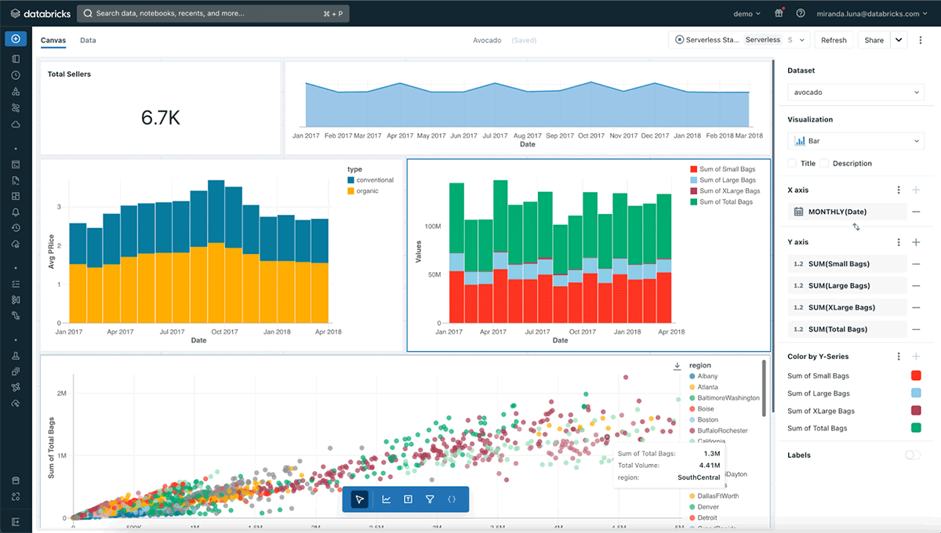
🎯 Business Use Case
Analyze orders, customers, products, payments.
🏗️ Architecture
Source (CSV + Streaming)
↓
Databricks (PySpark)
↓
Delta Lake (Bronze/Silver/Gold)
↓
BI Dashboard
🧱 Core Features
- Incremental ingestion
- SCD Type 2 customers
- Revenue & CLV analytics
- Performance optimization
📊 Gold Tables
- fact_orders
- dim_customers
- dim_products

🔷 MAJOR PROJECT 2
Airline / Travel Analytics Platform
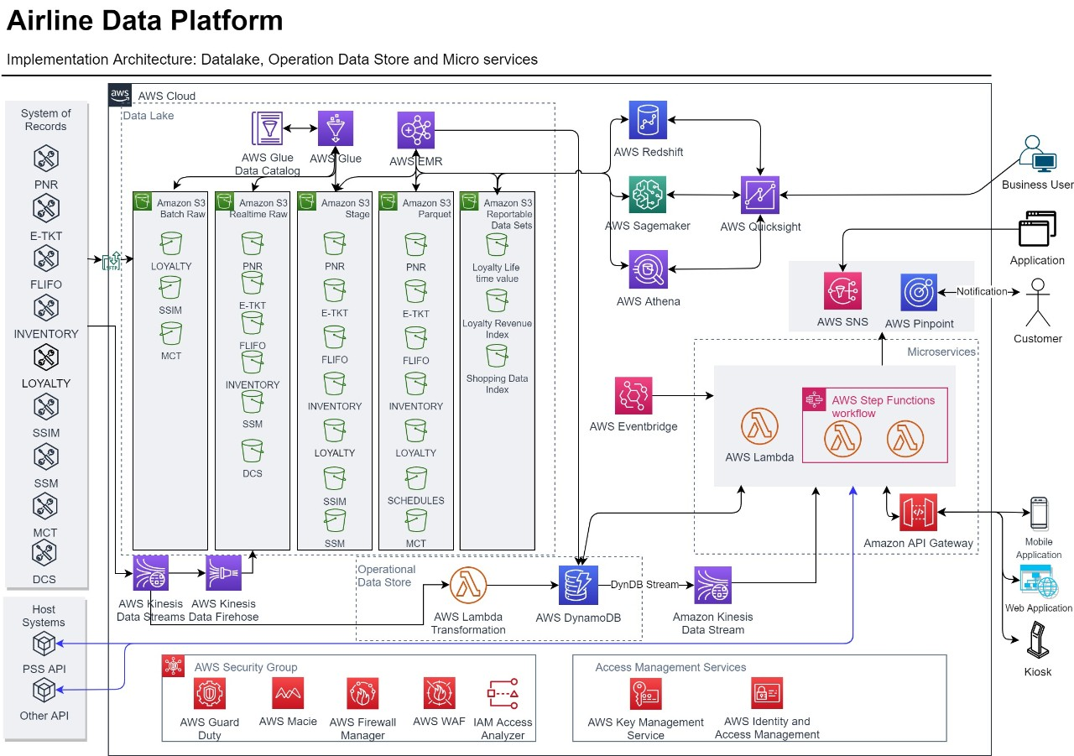
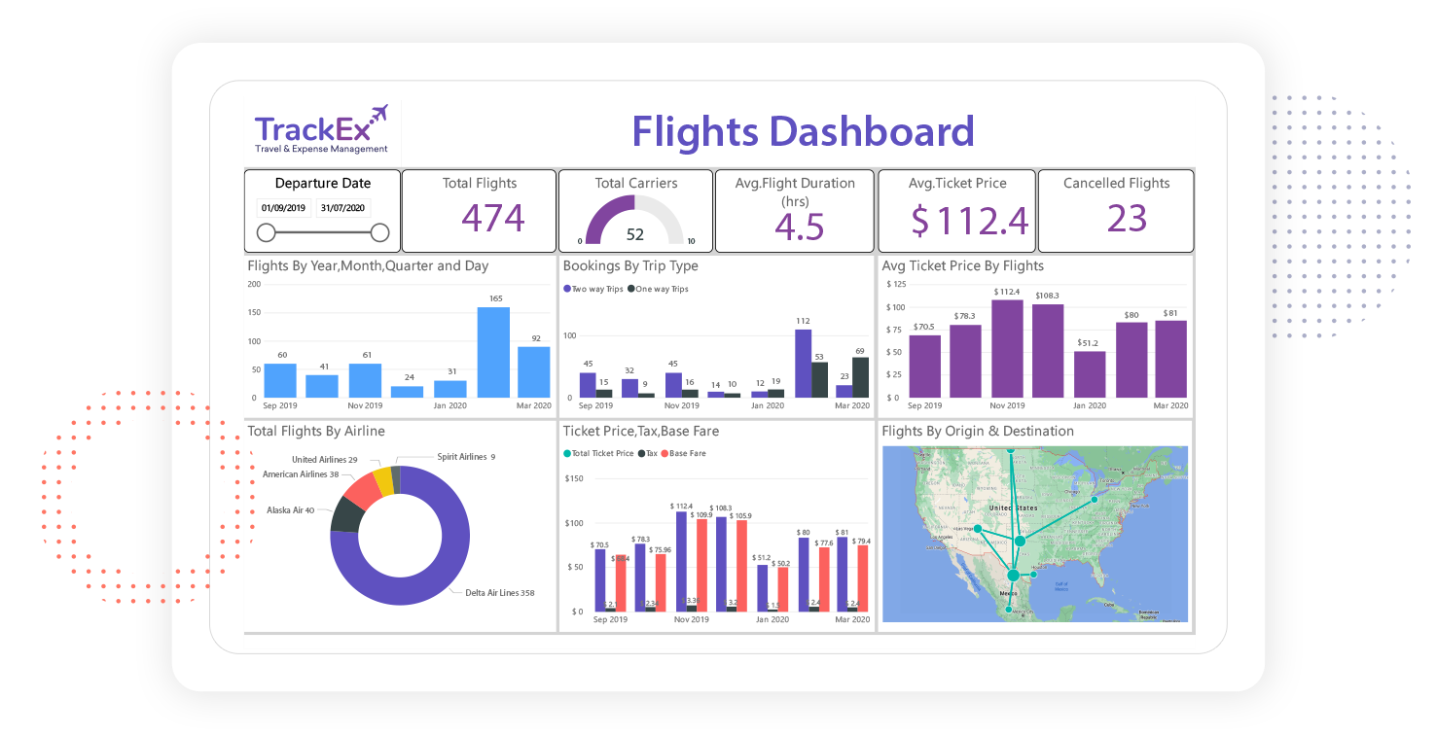
🎯 Business Use Case
Flight operations & booking analytics
(Perfect match to your current domain 👍)
🧱 Core Features
- Flight schedule ingestion
- Codeshare logic
- Seat availability analysis
- Delay & cancellation metrics
🧠 Advanced Concepts
- Late-arriving flights
- Snapshot fact tables
- Complex joins
- Incremental MERGE logic

🔁 REUSABILITY ACROSS PROJECTS
Component | Reused In
Bronze/Silver/Gold pattern | All projects
SCD framework | Retail + Airline
Streaming logic | Mini 2 + Retail
DQ checks | All
Optimization scripts | Major projects

Below is Mini Project 1 rewritten and expanded fully based on a REAL-WORLD business scenario, exactly how this would be implemented in an enterprise Databricks environment (Retail / E-commerce use case).
This is NOT demo-style — this is production-style content you can directly explain in interviews.

🔹 MINI PROJECT 1 (REAL-WORLD IMPLEMENTATION)
Retail Order Processing ETL using Delta Lake
(Bronze → Silver → Gold Architecture)
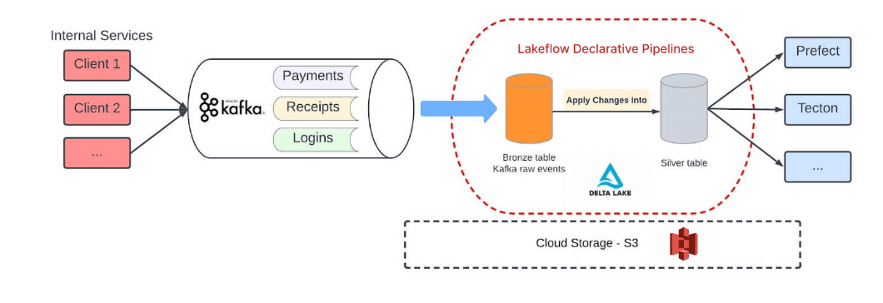
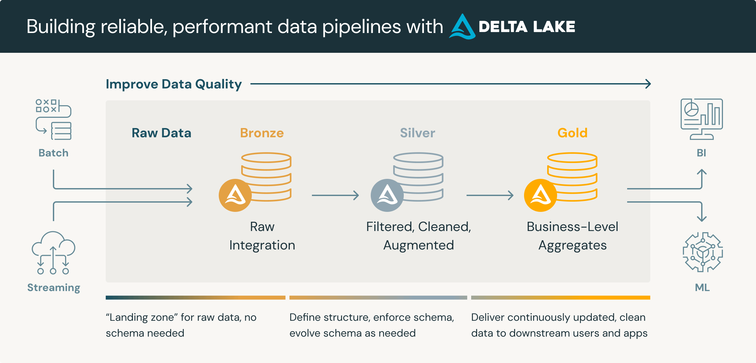

🏢 REAL-WORLD BUSINESS SCENARIO
Company Context
You are a Data Engineer working for a large e-commerce company (like Amazon / Flipkart).
Business Problem
- Orders are coming daily from multiple upstream systems
- Raw data quality is poor (duplicates, nulls, schema changes)
- Business teams need reliable daily sales metrics
- Data must be auditable, incremental, and re-processable
Solution
Implement a Databricks Lakehouse ETL pipeline using Delta Lake Medallion Architecture.

🎯 PROJECT OBJECTIVES (BUSINESS-DRIVEN)
✔ Handle raw data safely (audit & replay)
✔ Clean and standardize orders
✔ Generate analytics-ready metrics
✔ Support incremental loads
✔ Enforce data quality
✔ Enable rollback & debugging

🧱 ARCHITECTURE OVERVIEW
Raw Order Files (CSV / JSON)
↓
Bronze Layer (Raw + Audit)
↓
Silver Layer (Clean + Deduplicated)
↓
Gold Layer (Business Aggregates)
↓
BI / Reporting / Analytics

📁 REAL-WORLD PROJECT STRUCTURE
retail_order_etl/
│
├── notebooks/
│ ├── 00_env_setup
│ ├── 01_bronze_orders_ingestion
│ ├── 02_silver_orders_processing
│ ├── 03_gold_sales_analytics
│ └── 04_data_quality_framework
│
├── configs/
│ └── table_config.json
│
├── data/
│ └── raw_orders/
│
└── README.md

📌 STEP 0 – ENVIRONMENT SETUP (ENTERPRISE STANDARD)
Notebook: 00_env_setup
spark.sql("CREATE DATABASE IF NOT EXISTS retail_etl")
spark.sql("USE retail_etl")

spark.conf.set("spark.databricks.delta.schema.autoMerge.enabled", "true")

📘 NOTEBOOK 01 – BRONZE LAYER
Raw Order Ingestion (Audit Layer)
🎯 Business Purpose
- Preserve exact raw data
- Enable reprocessing
- Capture data lineage
Raw Data Example (from OMS)
order_id,customer_id,product_id,order_ts,quantity,price
1001,501,301,2025-01-01 10:12:00,2,499
1002,502,302,2025-01-01 11:45:00,1,1299
1002,502,302,2025-01-01 11:45:00,1,1299
Implementation
from pyspark.sql.functions import *
from pyspark.sql.types import *

schema = StructType([
StructField("order_id", IntegerType()),
StructField("customer_id", IntegerType()),
StructField("product_id", IntegerType()),
StructField("order_ts", TimestampType()),
StructField("quantity", IntegerType()),
StructField("price", DoubleType())
])

bronze_df = (
spark.read
.schema(schema)
.option("header", "true")
.csv("/FileStore/raw/orders/")
.withColumn("ingest_ts", current_timestamp())
.withColumn("source_system", lit("OMS"))
.withColumn("source_file", input_file_name())
)

(
bronze_df.write
.format("delta")
.mode("append")
.saveAsTable("retail_etl.bronze_orders")
)
✅ Why this matters (Interview Gold)
“Bronze is append-only to preserve audit history and support reprocessing.”

📘 NOTEBOOK 02 – SILVER LAYER
Clean & Trusted Orders
🎯 Business Purpose
- Remove duplicates
- Remove invalid records
- Standardize schema
Real-World Rules
- Duplicate order_id may arrive due to retries
- Orders with null price or quantity are invalid
- Only latest record per order is kept
Implementation
from pyspark.sql.functions import *
from pyspark.sql.window import Window

bronze_df = spark.table("retail_etl.bronze_orders")

window_spec = Window.partitionBy("order_id").orderBy(col("ingest_ts").desc())

silver_df = (
bronze_df
.withColumn("rn", row_number().over(window_spec))
.filter(col("rn") == 1)
.drop("rn")
.filter(col("quantity") > 0)
.filter(col("price") > 0)
)

(
silver_df.write
.format("delta")
.mode("overwrite")
.saveAsTable("retail_etl.silver_orders")
)
✅ Why overwrite?
Silver is idempotent — safe to re-run without duplication.

📘 NOTEBOOK 03 – GOLD LAYER
Sales Analytics (Business Ready)
🎯 Business Questions
- What is daily revenue?
- How many orders per day?
- Used by dashboards & leadership reports
Implementation
from pyspark.sql.functions import *

silver_df = spark.table("retail_etl.silver_orders")

gold_df = (
silver_df
.withColumn("order_date", to_date("order_ts"))
.groupBy("order_date")
.agg(
sum(col("quantity") * col("price")).alias("daily_revenue"),
countDistinct("order_id").alias("total_orders")
)
)

(
gold_df.write
.format("delta")
.mode("overwrite")
.partitionBy("order_date")
.saveAsTable("retail_etl.gold_daily_sales")
)
🚀 Optimization (REAL WORLD)
OPTIMIZE retail_etl.gold_daily_sales ZORDER BY (order_date);
VACUUM retail_etl.gold_daily_sales RETAIN 168 HOURS;

📘 NOTEBOOK 04 – DATA QUALITY FRAMEWORK
Production Validation
🎯 Purpose
Catch bad data before BI
Business Rules
- Quantity must be > 0
- Price must be > 0
from pyspark.sql.functions import *

silver_df = spark.table("retail_etl.silver_orders")

dq_df = (
silver_df
.filter((col("quantity") <= 0) | (col("price") <= 0))
.withColumn("dq_issue", lit("Invalid quantity or price"))
)

dq_df.write.mode("overwrite").saveAsTable("retail_etl.dq_issues")

🧪 REAL-WORLD TEST SCENARIOS
Scenario | Expected Result
Duplicate file arrives | Bronze stores, Silver dedupes
Bad record arrives | Logged in dq_issues
New column added | Auto schema merge
Job rerun | No duplication

🚀 DEPLOYMENT (ENTERPRISE WAY)
Databricks Job Flow
Bronze → Silver → Gold → DQ
Job Features
- Retry enabled
- Parameterized paths
- Alert on failure

🧠 HOW YOU EXPLAIN THIS IN INTERVIEWS
“We use Bronze for auditability, Silver for clean trusted data, and Gold for business analytics. Delta Lake enables schema evolution, time travel, and efficient incremental processing.”

